Prepared By: Rabbi Wasti

Detection of Brute Force and Port Scanning Attacks Using Splunk SIEM

Table of Contents
Abstract 3
1. Problem Statement 3
2. Objectives 3
3. Architecture &Environment 4
4. Tools & Technologies 4
5.Attack Simulation 4
6.Brute Force Detection 6
7.Port Scan Detection 9
8.Result 11
9.Security Analysis 11
10.Security Impact 11
11.Future Enhacenents 12
Conclusion 12

Abstract
This project illustrates how the Security Operations Center (SOC) simulation could be implemented with the help of Splunk SIEM. The actual cyberattacks like SSH brute-force and network port scanning were simulated with the help of Kali Linux. The detection and analysis of these attacks were performed on centralized log monitoring in Splunk, with alerts being set up to mimic enterprise SOC detection workflows.

1. Problem Statement
Unauthorized access and reconnaissance attacks are constant threats to organizations. These threats are not detected without a SIEM system. This project will attempt to model these attacks and illustrate the detection and notification of security teams by SIEM tools.

2. Objectives

- Simulate brute-force and port scan attacks
- Centralize logs using Splunk Forwarder
- Analyze authentication and system logs
- Identify attacker IP addresses
- Create automated SOC alerts

3. Architecture &Environment
Component | Role
Kali Linux | Attacker
Fedora Linux | Victim
Splunk Enterprise | SIEM
Splunk Forwarder | Log Collector

4. Tools & Technologies
- Splunk Enterprise
- Splunk Universal Forwarder
- Hydra
- Nmap
- Kali Linux
- Fedora Linux

5.Attack Simulation
6.1 SSH Brute Force Attack
A password-guessing attack attempting unauthorized system access.
Tool Used: Hydra
Command executed on Kali:
hydra -l root -P /usr/share/wordlists/rockyou.txt ssh://192.168.1.48
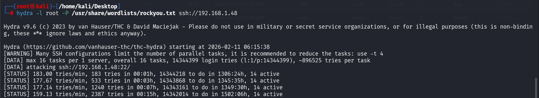
Figure 1:Kali terminal showing Hydra brute force attack.
(Source:-Self-creation)
6.2 Port Scanning Attack
Reconnaissance activity to identify open services.
Tool Used: Nmap
Command:
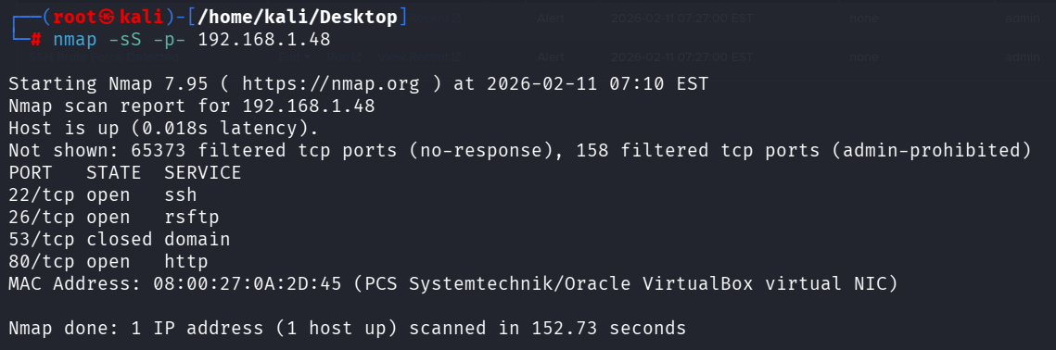
nmap -sS -p- 192.168.1.48
Figure 2:Kali terminal showing Nmap open ports
(Source:-Self-creation)
6.3 Log Collection & SIEM Integration
Fedora system logs (/var/log/secure, /var/log/messages) were forwarded to Splunk using Universal Forwarder.
Search:
index=* host=fedora
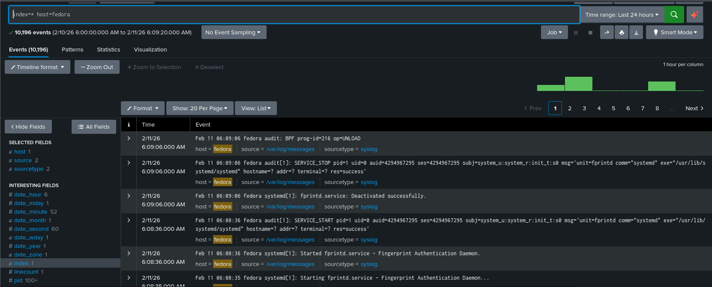
Figure 3:Splunk showing Fedora system logs.
(Source:-Self-creation)
This confirmed successful log ingestion.

6.Brute Force Detection
6.1 Raw Log Identification
"Failed password"
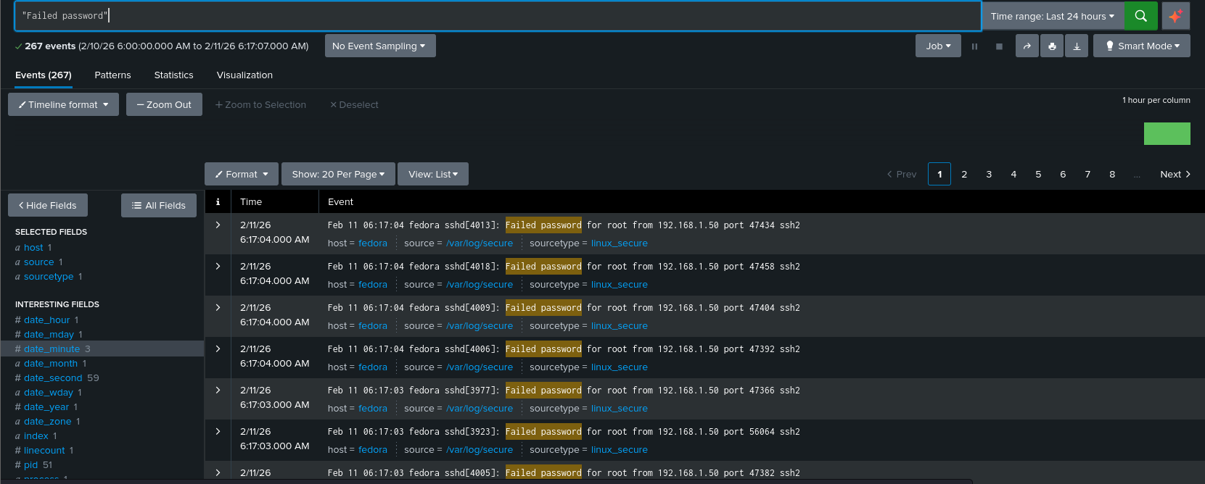
Figure 4:Multiple failed SSH login events.
(Source:-Self-creation)
This filters SSH authentication failures.
6.2 Attacker IP Extraction
"Failed password"
| rex "from (?<attacker_ip>\d+\.\d+\.\d+\.\d+)"
| stats count by attacker_ip
| sort -count
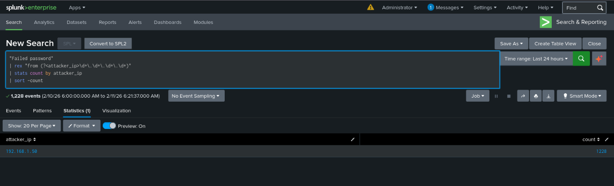
Figure 5:Table showing attacker IP and count
(Source:-Self-created)
This query:
- Filters failed login attempts
- Extracts the attacker IP
- Counts login attempts
- Flags excessive activity
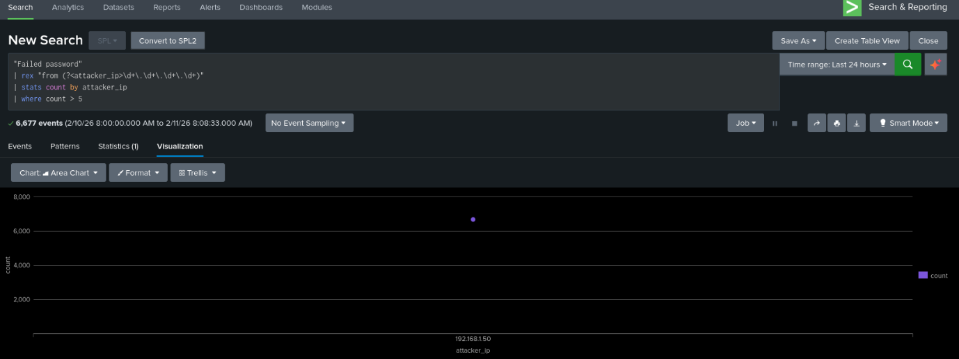
Figure 6:Visualization showing attacker_ip vs count
(Source:Self-created)
The visualization clearly shows a spike in login attempts from IP 192.168.1.50, indicating
brute-force behavior.
6.3. Brute Force Alert
Alert Name: SSH Brute Force Detected
Trigger: Per result
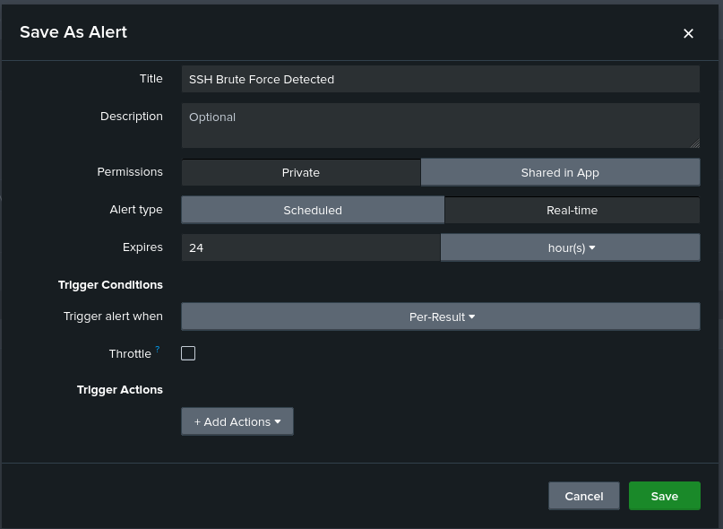
Figure 7:Alert creation page
(Source:Self-created)

7.Port Scan Detection
Search:
index=* host=fedora (ssh OR failed OR refused OR nmap OR scan OR denied OR rejected)
| rex "from (?<attacker_ip>\d+\.\d+\.\d+\.\d+)"
| stats count by attacker_ip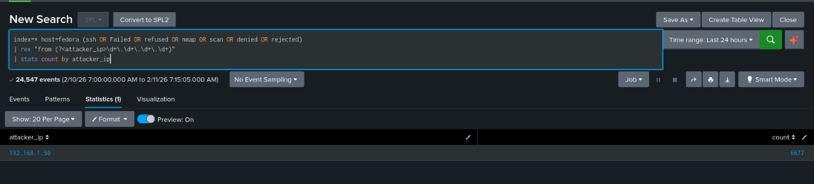
Figure 8:Attacker IP detected with high event count.
(Source:Self-created)
This query:
- Correlates suspicious connection attempts
- Extracts attacker IP
- Aggregates event counts
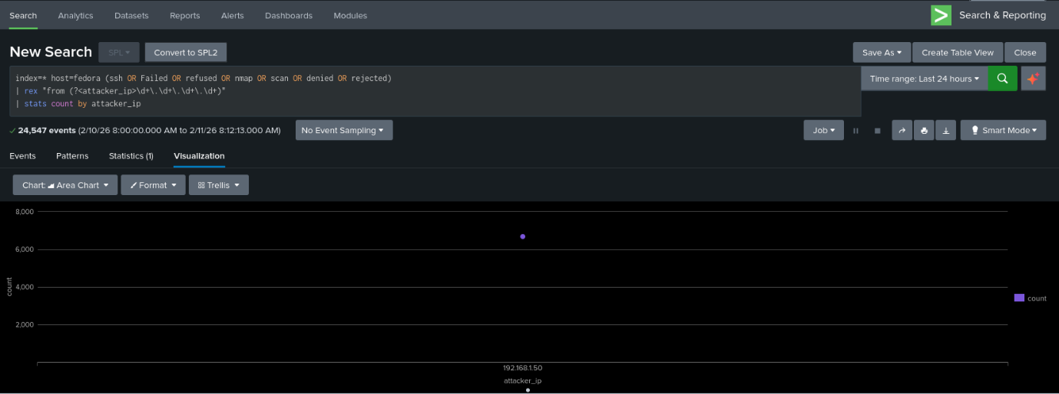
Figure 9:Visualization graph of port scan activity
(Source:Self-created)

The graph highlights a significant volume of suspicious activity originating from the attacker IP, confirming reconnaissance behavior.
7.1 Port Scan Alert
Alert Name: Port Scan Detected
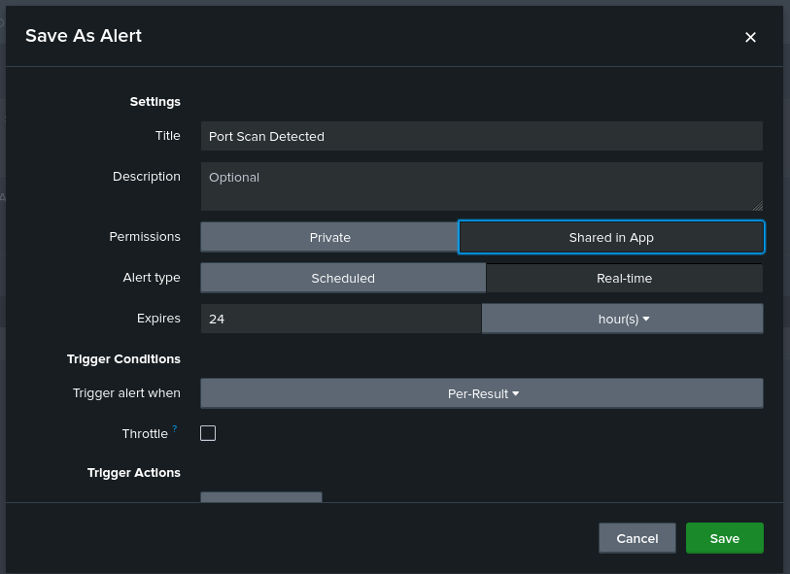
Figure 10:Port Scan alert creation screen
(Source:Self-created)

8.Result
Attack | Attacker IP | Events
Brute Force | 192.168.1.50 | 1228+
Port Scan | 192.168.1.50 | 6677+

9.Security Analysis
The following threat patterns were successfully detected:
Attack | MITRE Technique | Result
SSH Brute Force | T1110 | Identified attacker IP
Port Scan | T1046 | Detected reconnaissance

10.Security Impact
- Early detection of unauthorized access
- Identification of threat actor IP
- Automated alerting for SOC teams

11.Future Enhacenents
- Geo-IP correlation
- Threat intelligence integration
- SOAR automation
- Dashboards

Conclusion
This SOC simulation successfully demonstrated how SIEM tools like Splunk can detect and alert on real-world cyber threats.
The system effectively identified attacker behavior and generated security alerts, simulating an enterprise SOC workflow.

